Get Out Get Active

Returning to Activity in North and North East Lincolnshire
The Get Out Get Active programme in North & North East Lincolnshire is a physical activity programme supporting the most inactive 55-74-year old’s to become more active by developing an inclusive and intergenerational offer.

In response to COVID-19 the programme has focused on a couple of new ways to engage the key target audience; Active Humber developed Stay Active at Home pages to encourage people affected by lockdown to be physically active in their own homes, alongside this a Stay Active at Home GOGA leaflet was developed and distributed with food/care packages, community emergency response teams and other partners agencies to support those who may not have access to the internet to undertake light exercises in their homes.

Since restrictions have eased Active Humber have been working with partners in North East Lincolnshire to develop bowls and croquet sessions at a local park in Grimsby. Sessions run twice a week and are fully inclusive. The sessions have attracted a range of ages and abilities and are fully adapted to cater for the range of participants that attend.

We take a look at some of the responses from the GOGA participants so far:
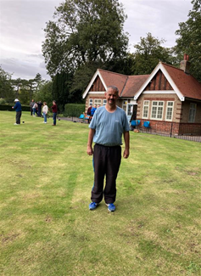

Peter:
Is 48 years old and has epilepsy and anxiety. Peter was walking through the park and saw the sessions taking place and was invited to join in. Peter enjoys the sessions as it has helped him meet new people, and other people with anxiety.

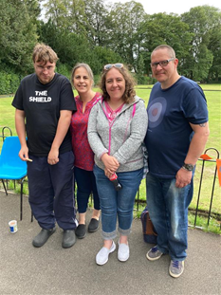
The Whitehead Family:
Mum Leanne, Dad Adrian and children Alex and Stephanie have attended the bowls sessions almost every week since they started and describe the sessions as the best thing ever" and "one of the few things that they can all do together as a family”. They have even gone out and purchased their own bowls as they enjoy the sessions that much. They feel this will support Alex and Stephanie to return to other activities as lockdown restrictions ease further.

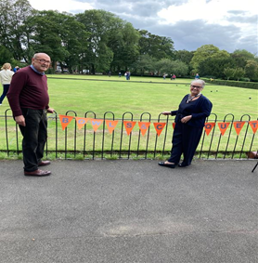
Debbie and Bill:
Debbie is 55 years old and the ward councillor for the ward the activity is taking place in. Debbie brings a whole new dimension to the sessions with the provision of homemade light refreshments which everyone loves. Debbie has made some advertising bunting and notices to attract people to the sessions and uses her vast knowledge to support participants by signposting them to other services in the area which could be of benefit to them.
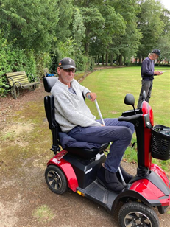

Nigel:
Nigel is 53 years old and has various health conditions which affect his mobility. Nigel has attended every session so far and the sessions are the only form of exercise he undertakes. At 6 foot 5 inches playing croquet was initially a challenge for Nigel as the height of the mallet caused him some pain. However, to support his participation in the sessions the coaches went away and created a longer mallet for Nigel which meant he could participate in the sessions.

